**Experiment No : 04**

**Experiment Name :** Digital Communication Through Optical Fiber.

**Objective:**

This study is to study a 660nm & 950nm fiber optic digital link. Here you will study how digital signal can be transmitted over fiber cable &reproduced at the receiver ends

**Theory:**

Fiber optics can be used for transmission of digital as well as analog signal. Basically a fiber optics link contains three main elements, a transmitter, optical fiber and receiver. The transmitter modules take the input signal in electrical form and then transform it into optical energy containing the same information. The optical fiber is the medium, which takes the energy to the receiver. At the receiver light is converted back into receiver into electrical form at the same pattern as to originally fed to the transmitter

**Apparatus:**

**Transmitter:** Led digital dc coupled transmitters are one of the most popular varieties due to their ease of fabrication. We have used a standard TTL gate to drive a NPN transistor, which modulates the LED SFH 756V source. (Turns it on & off).

**Fiber Optic Link:** Emitter and detector circuit on board form the fiber optic link. This section provides the light detector at the far end of the fiber optic links. The optic fiber plugs into the connectors provided in this part of the board. Two separate links are provided.

**The Receiver:** SFH-551V is a digital optodetector. It delivers a digital output, which can be processed directly with little additional external circuitry. The integrated circuit inside the SFH551V optodetector comprises the photo diode device, a Tran’s impedance amplifier, a comparator and a level shifter. The photo diode converts the detected light in to a photo current. With the aid of an integrated lens the emanating from the plastic fiber is almost entirely focused on the surface

of the diode. At the next stage the trans-impedance amplifier converts the photo current into a voltage. In the comparator, the voltage is compared to a reference voltage. In over to ensure good synchronism between the reference and the trans-impedance output voltage, the former is derived from a second circuit of a similar kind, which incorporates a “blind” photo diode. The comparator derives a level shifter with an open collector output stages. Here a catch diode (similar to Schottky-TTL) prevents the saturation of the output transistor, thus limiting the output voltage to the supply voltage.

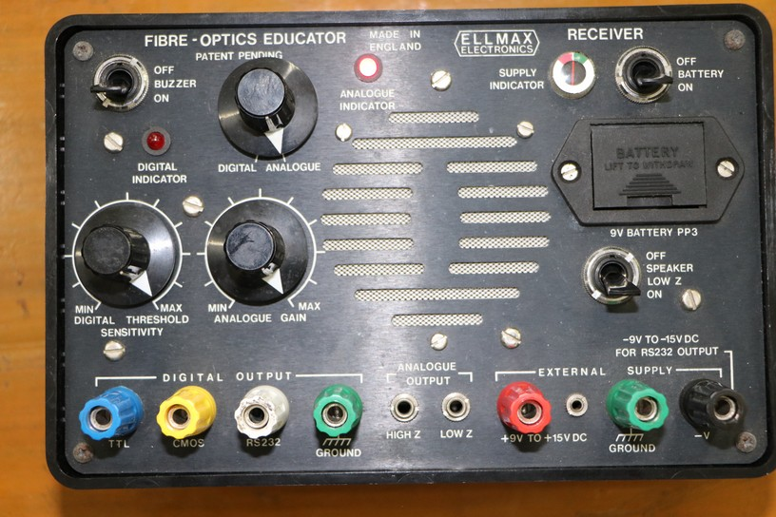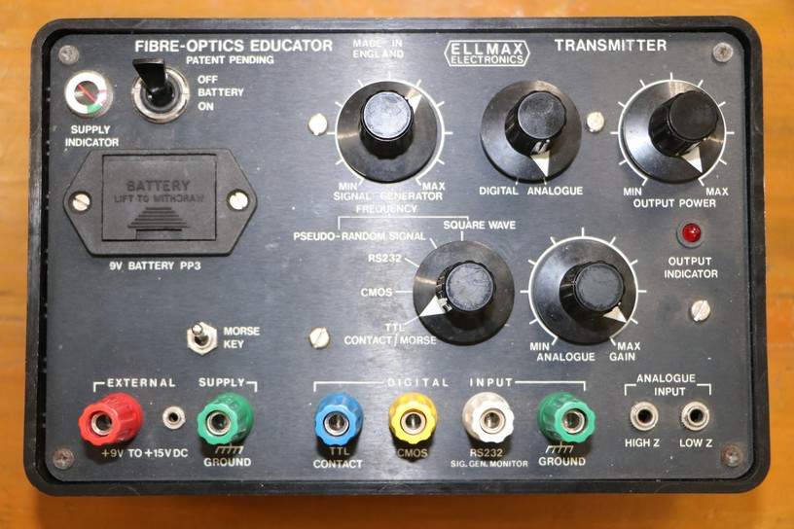 **Transmitter Receiver**

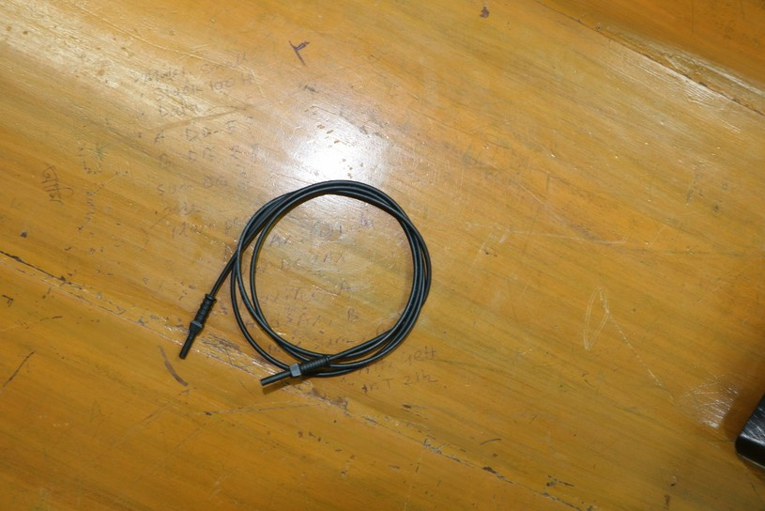

**Fiber optic Link**

**Procedure:**

* Connect the power supply to the board.
* Make the optical fiber connections properly
* Switch on the power supply.
* Feed TTL square wave signal of 1 KHz from the function generator to the in post of digital buffer.
* Connect the output post out of digital buffer to the post TX in of transmitter
* Observe that digital output on the receiver by Digital indicator and signal sound.
* Try a reflector removing the optical fiber and observe the output signal quality.